#### **Project 01**

#### **Problem Statement**

You are tasked with deploying a three-tier web application (frontend, backend, and database) using Ansible roles. The frontend is an Nginx web server, the backend is a Node.js application, and the database is a MySQL server. Your solution should use Ansible Galaxy roles where applicable and define appropriate role dependencies. The deployment should be automated to ensure that all components are configured correctly and can communicate with each other.

#### **Deliverables**

1. **Ansible Project Directory Structure**

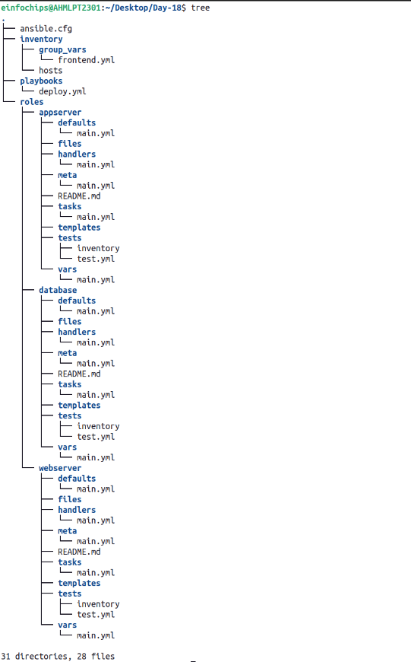

1. **Role Definitions and Dependencies**

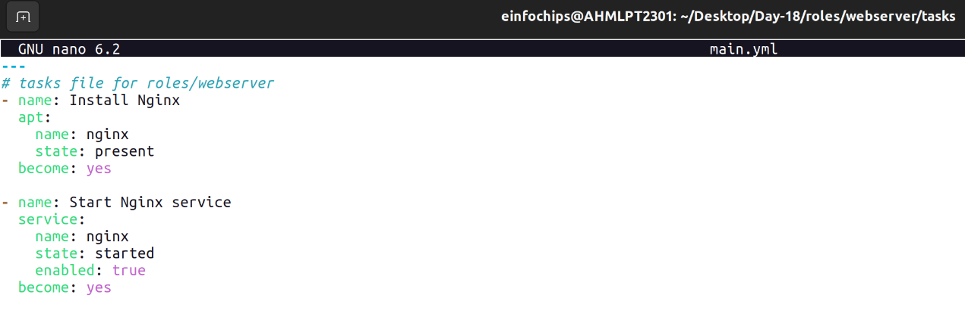

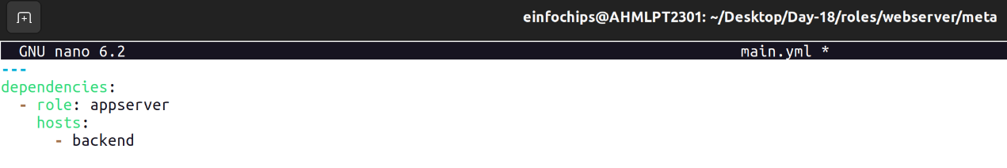

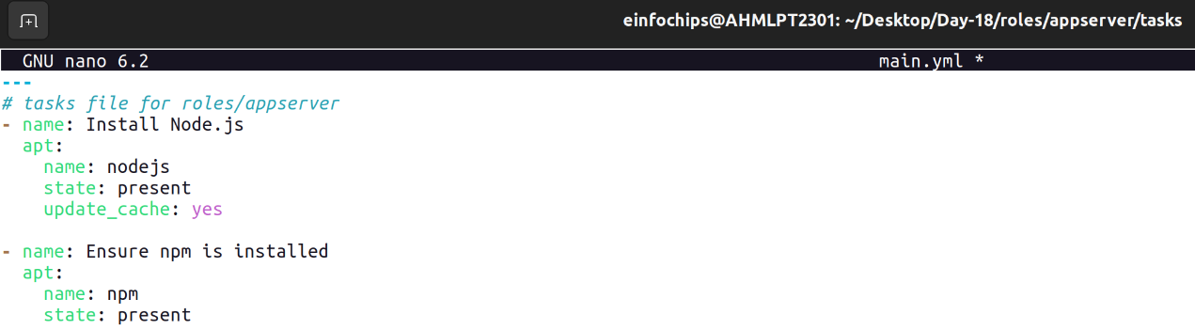

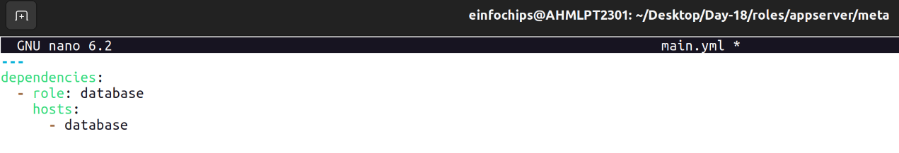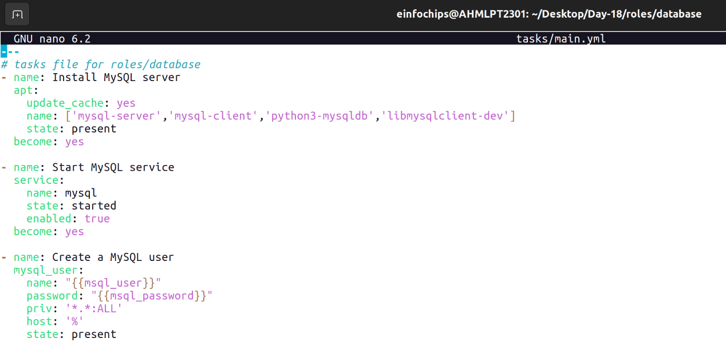

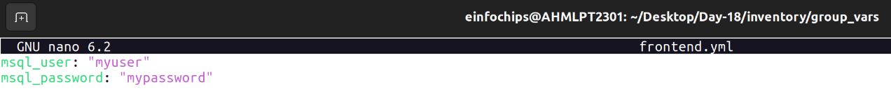

1. **Inventory File**

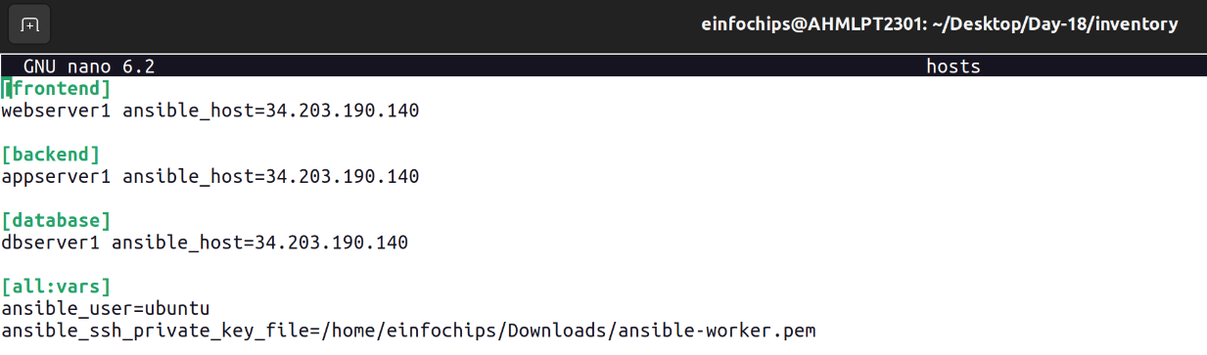

1. **Playbook for Deployment (deploy.yml)**

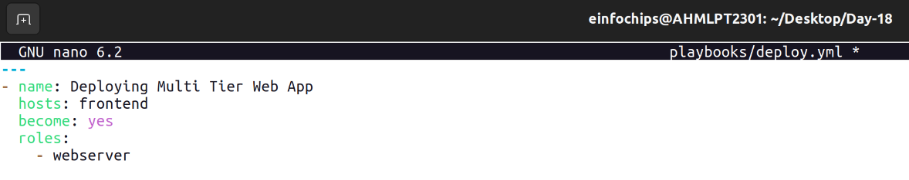

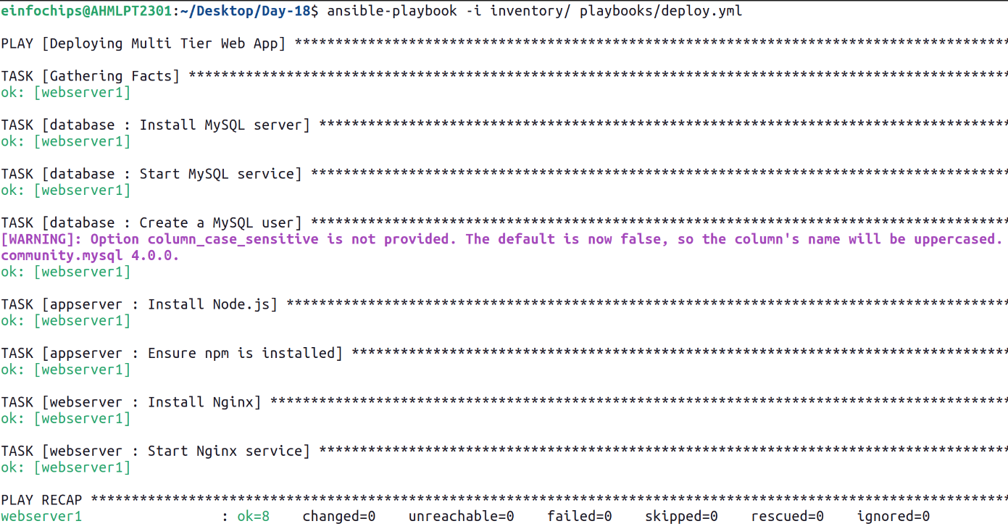

1. **Playbook for Testing (test.yml)**

